Christmas Dates
December 2018

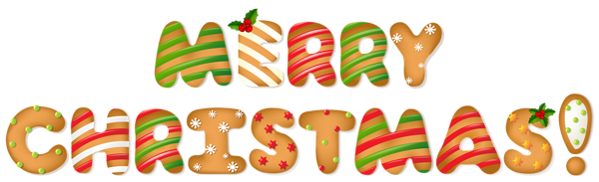
Nursery will confirm their own arrangements
Date | Class / Classes | Event | Times
Thursday 15th Nov | - | Shopping Evening | 7- 9pm
Saturday 1st | Whole School | Christmas Fair | 12 noon – 2pm
Monday 3rd |  | Practice Day
Tuesday 4th |  | Practice Day
 |  | Practice Day
Wednesday 5th | P1K / P2/1D / P3LB | Performance 1 | 9.30 – 10.30
 | P1M / P2FG / P3/2M | Performance 2 | 11.15 – 12.15
Thursday 6th | P4M / P5B / P6/7W / P7W | Performance 1 | 9.30 – 11.15
 | P4J / P5MB / P6J / P7C | Performance 2 | 1.30 – 2.45
Monday 10th | Whole School | Pantomime | PM
Thursday 13th | P6 | Party | 1.30 – 3.15
Friday 14th | P5 | Party | 1.30 – 3.15
Monday 17th | P3 | Party | 1.30 – 3.15
 | Nursery B | Party | AM
 | P7’s | Visit to Ellon Cinema | PM
Tuesday 18th | P4 | Party | 1.30 – 3.15
 | Nursery A | Party | AM
Wednesday 19th | P2 | Party | 1.30 – 3.15
 | P7 | Party | AM
Thursday 20th | Whole School | Assembly (t.b.c.) | 9.30 – 10.15
 | P1 | Party | 1.30 – 3.15
Friday 21st | P1 - P7 | Christmas Lunch | 12 noon – 1.30

